YUVA INTERNSHIP
Junior Data Analyst – Agribusiness
Task 4 : Agribusiness Initiative

INTRODUCTION

Tomatoes are a staple crop in India, widely cultivated and consumed across the country. Despite their economic importance, the tomato supply chain faces significant challenges, particularly in post-harvest handling and distribution. In Telangana, smallholder farmers often suffer losses due to inadequate cold storage, inefficient logistics, and market volatility. These issues result in reduced incomes, food waste, and inconsistent supply to consumers.
This report presents a cost-benefit analysis of a proposed agribusiness initiative aimed at establishing cold chain infrastructure for tomato farmers in Telangana. The initiative seeks to reduce spoilage, improve product quality, stabilize market prices, and enhance farmer livelihoods through targeted investments in storage, transport, and training.

Initiative Definition

1. Cold Storage Infrastructure
- Installation of 10 modular cold storage units, each with a capacity of 5 metric tons, strategically placed in high-yield tomato clusters.
- These units will operate on solar-assisted hybrid energy systems to ensure reliability in off-grid areas.
- Equipped with temperature and humidity monitoring for optimal preservation.

2. Refrigerated Transport Fleet
- Procurement of 5 refrigerated trucks designed for short-haul regional distribution.
- Trucks will be managed by local cooperatives or transport unions to ensure community ownership.
- GPS-enabled routing and scheduling to minimize transit time and fuel usage.

3. Rural Collection & Processing Centers
- Establishment of multi-functional collection hubs with facilities for:
  - Grading and sorting based on size, ripeness, and quality
  - Eco-friendly packaging using biodegradable crates
  - Digital inventory tracking to streamline aggregation and dispatch
- These centers will serve as aggregation points for nearby villages, reducing individual transport burdens.

4. Farmer Training & Capacity Building
- Hands-on workshops and digital modules on:
  - Post-harvest handling best practices
  - Cold storage operations and maintenance
  - Quality standards for institutional and urban buyers
- Delivered in local languages with support from agricultural extension officers and NGOs.

Cost Analysis

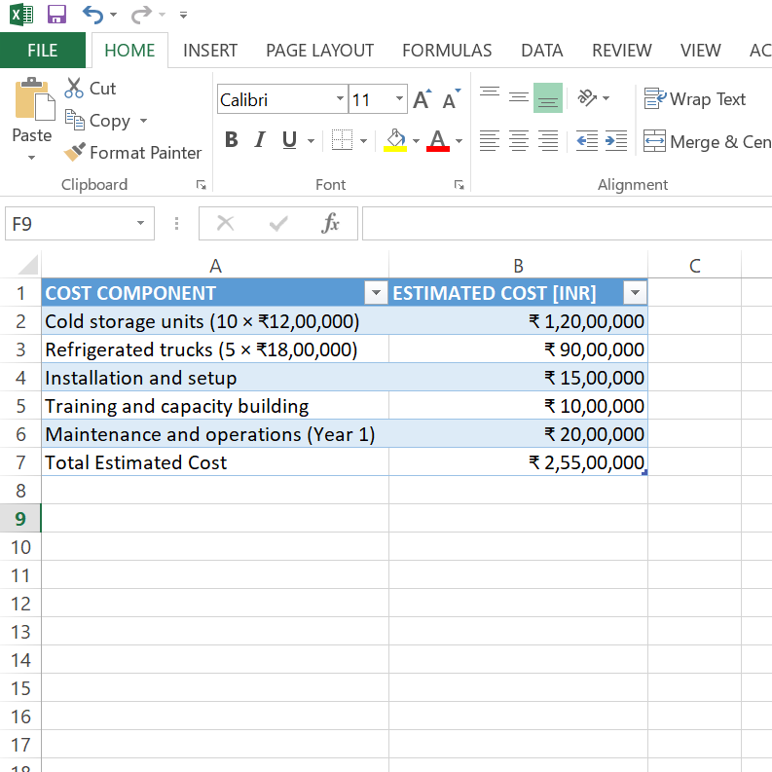

Benefit Analysis

Quantifiable Benefits
- Reduction in Post-Harvest Losses: Current losses of up to 30% can be reduced to 10%, saving approximately ₹1.5 crore annually across participating farmers.
- Improved Market Prices: Enhanced quality and shelf life can lead to 15–20% higher prices, increasing farmer income by approximately ₹50 lakh annually.
- Expanded Market Access: Cold chain infrastructure enables supply to urban markets and institutional buyers, generating an estimated ₹30 lakh in new revenue streams.
- Employment Generation: The initiative will create approximately 50 direct and indirect jobs in storage, transport, and training services.

Intangible Benefit

- Increased farmer confidence and participation

- Improved food safety and consumer satisfaction

- Strengthened rural infrastructure and agribusiness ecosystem

- Enhanced resilience to climate and market shocks

Methodology

Approach Used
To evaluate the financial viability of the initiative, the following methods were applied:
- Net Present Value (NPV)
- Benefit-Cost Ratio (BCR)
- Time horizon: 5 years
- Discount rate: 10%

Calculations
Total Benefits (5 years): Annual benefit = ₹1.5 crore + ₹50 lakh + ₹30 lakh = ₹2.3 crore 5-year benefit = ₹2.3 crore × 5 = ₹11.5 crore
NPV Calculation: NPV = ₹11.5 crore / (1 + 0.10)^5 – ₹2.55 crore ≈ ₹7.13 crore
Benefit-Cost Ratio (BCR): BCR = ₹11.5 crore / ₹2.55 crore ≈ 4.5
These results indicate a strong return on investment and long-term sustainability.

Risk Assessment

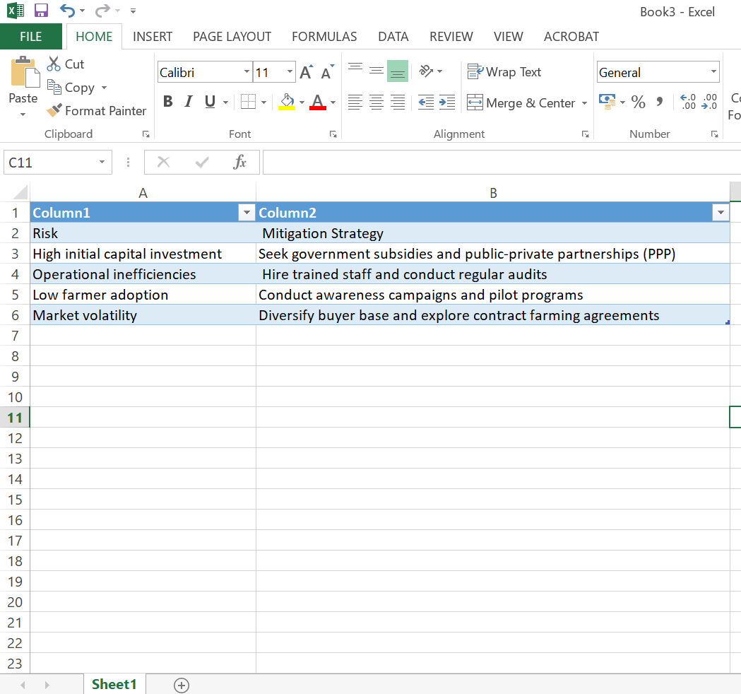
Proactive risk management will ensure smooth implementation and long-term success.

CONCLUSION
The proposed cold chain infrastructure initiative offers a transformative solution to the persistent inefficiencies in the tomato supply chain. With a Benefit-Cost Ratio of 4.5 and a Net Present Value of over ₹7 crore, the project demonstrates strong economic viability and social impact. It promises to reduce post-harvest losses, stabilize prices, improve product quality, and uplift farmer incomes.
Beyond financial returns, the initiative contributes to rural development, food security, and agribusiness modernization. It empowers farmers, creates jobs, and strengthens the supply chain from farm to market.

Recommendation: Proceed with phased implementation, beginning with pilot clusters, and scale based on performance metrics and stakeholder feedback. This initiative represents a strategic opportunity to modernize the tomato supply chain and unlock long-term value for all stakeholders involved.

THANK YOU

